“Rushmoor Christmas Angels” Newsletter February 2026

Hello everyone and welcome to our February newsletter. A big welcome to you if you have recently joined the RCA Team and this is your first newsletter.

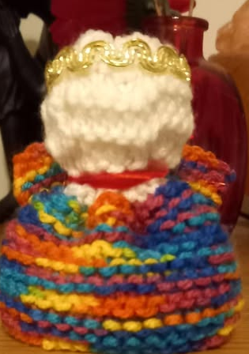
It was lovely to see you all a couple of weeks ago at our first knitting party of the year… as well as seeing the start of this year’s “Heavenly host” coming together. Below is one of the first angels of 2026.

In January the “Rushmoor Christmas Angels” Facebook page hit 4000 followers. How amazing is that?

As some of you will have already seen we received the following message on Facebook just recently


“Hi there, I spoke to someone associated with Rushmoor Angels when I visited Hope church Carol Service at the Garrison Church in December. They told me to message you to get a copy of the pattern you use. I do not live near Aldershot but we thought it was such a lovely idea that we would like knitters associated with the church we attend to think about knitting some for Christmas 2026 and distributing them in our village Thank you for your help. What a blessing your ministry is to those who receive one of your angels. I have one in my hand as I write to you xx”

Over the time our project has been running a number of other projects have started up as knitters from RCA have moved away and started up a similar projects in their new location. I heard of another “Angel” project that started up this past Christmas that was “inspired” by our project here in Rushmoor. Acocks Green in Birmingham launched last year and on behalf of RCA I sent them our best wishes as their project got underway.

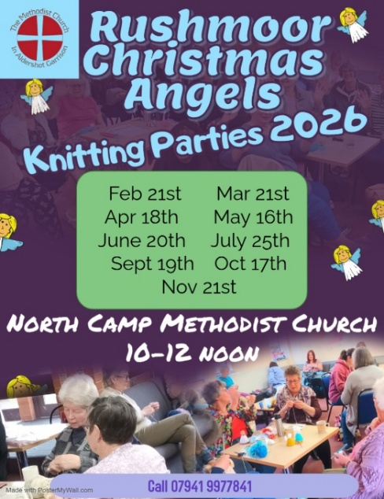
As I have often said before, I did begin keep track of the number of other projects that have “started up” off the back off RCA. I have given up counting now but the total is probably not far off 25.

I know it sounds obvious but there are now just 11 months until Rushmoor Christmas Angels 2026 launches . Although we often joke about mentioning the launch of our project as early as February, we have learnt over the past years that, so far as RCA is concerned, Christmas seems to come around really fast, (or is that just me just getting old?)

For those of you who like to be organised the dates for our future knitting parties during 2026 are right here.

David

