Rushmoor Christmas Angels newsletter April 2026

Hello everyone and welcome to RCA newsletter for April 2026
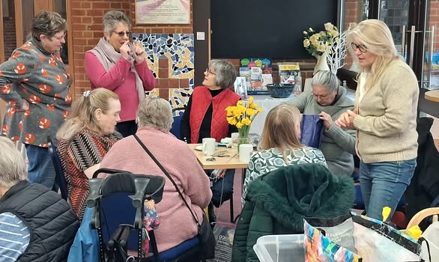
If this is your first “Newsletter” can we say firstly welcome, it is great to have you on board.

Spring has sprung, the daffodils are out, and yes — we are still thinking about Christmas! While the rest of the world is sowing seeds, we are still stitching wings and mending halos. After all, angels don’t knit themselves do they… although wouldn’t that be a miracle worthy of announcement? 😉

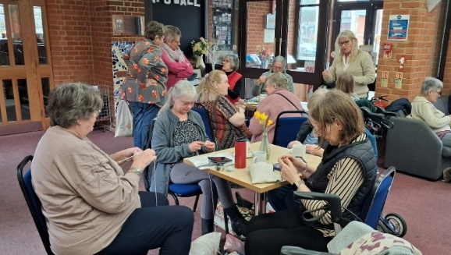
This month as little seeds are planted in the ground we too can celebrate the power of the “little things”. A small knitted angel tucked into a letterbox, left in a shopping trolley, placed on a shelf in a shop or hung on a Christmas wreath in December can carry enormous love and encouragement. Never underestimate the ministry of a miniature halo!

Did you know the earliest surviving knitted items date back to the 11th century and it also takes roughly 260 metres of yarn to knit an average adult jumper — thankfully our little angels are a little less demanding! Knitting is also proven to reduce stress and lower heart rate. So technically… as we knit our angels we are engaging in festive cardio, although it has to be said with all the “side projects” running at the moment heart rates are up this year.
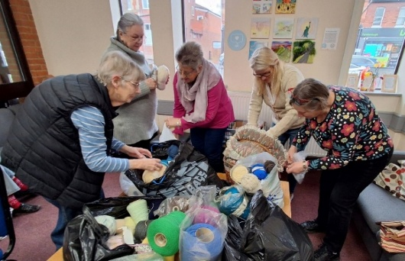
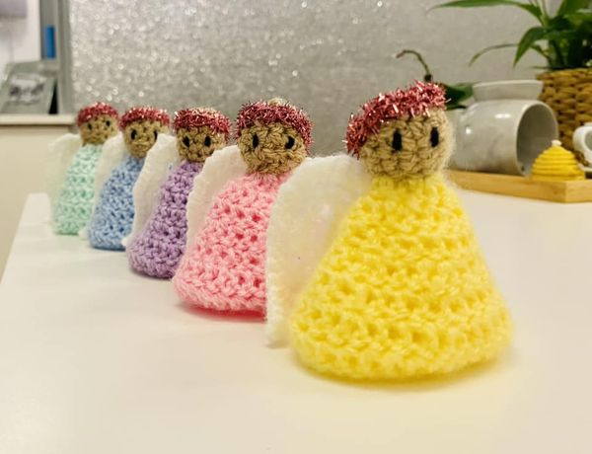
I came aross this story just recently. “Jean found a knitted angel in the most undignified of places — the frozen section at the supermarket. It was wedged between frozen peas and Potato waffles. A tiny label read: “take me”. Jean looked around suspiciously. Was this a new supermarket loyalty scheme? “Buy one apple strudel and get a knitted angel free. She popped the angel in her trolley and headed for the tills. At the checkout, the cashier grinned. “Oh good — you found one! The lovely ladies hide these around town” Jean beamed all the way home. She’d only gone out for Lasagne, but found love……— and inspired by her angelic “find” treated herself to two packets of angel delight for dessert”.

Spring certainly lifts our spirits and gives us a burst of colour, but remember: Christmas gold, snowy white, and heavenly sparkle never go out of style. If you spot any good yarn bargains, share the joy — angels thrive on good deals.

Our next “Knitting party” is on Saturday April 18th. As usual there will be tea, cake and coffee plus celestial conversation. So, until then keep those needles clicking and halos glowing. Every stitch is a blessing in disguise.

Stay woolly and wonderful! 🧶✨
David

