“Rushmoor Christmas Angels” November 2023

Hello everyone.

One more month to go until we launch RCA 2023…..who is excited?

Having just recently put our clocks back an hour it is, to coin a phrase “beginning to feel a lot like Christmas” and If you are anything like me you are wondering where 2023 has gone.

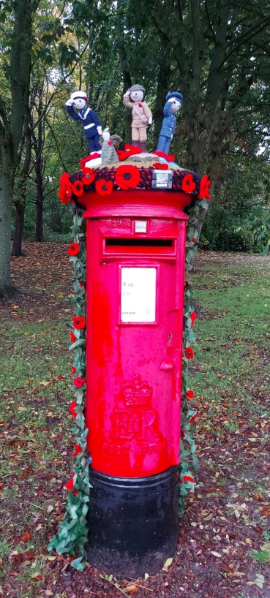With just one more knitting party until RCA 2023 launches we need to begin making sure we have everything in place ready so we are ready to go on 4th December. There are loads of labels available so if you need any before 25th November just let me know. If you have any angels that need label attaching do bring them along to the next “Knitting Party”

A few weeks ago we placed a Remembrance Post Box Topper on the post box outside North Camp Post Office. We shared some photos on social media. Within a week this post had received over 3000 reactions, almost 200 comments and over 300 shares. Well done Jackie.



A second “Post Box Topper” was placed on the post box on Badajos Road (just the hil from Aldershot Centre for Health). This “Topper” is within the garrison and also on a busy school run route so hopefully will be seen by loads of people, especially children…well done to everyone who contributed to this “Topper”,it looks amazing.

We are holding our annual “Rushmoor Christmas Angels” dedication carol service on Thursday 30th November. Please bring along all your knitted angels so we can make sure they go to those who will help us distribute. This service in effect kick starts our project each year. When we meet we have the opportunity to look back at the many stories we hear each year about how people found our angels at “just the right time”, and we also have time to pray that God will bless our endeavours again this Christmas. We also get the chance to belt out some classic Christmas carols ☺ which is always fun!

As always a massive thank you to ALL of you for all that you do to make this project what it is….it would not be the same without YOU. I look forward to seeing you all soon.

Please note change of address below in case you are intending to drop of any angels. Same road just 20 or so properties further along.

David Betts, 43 Redvers, Buller Road, Aldershot, GU11 2LY. [dabetts4x4@btinternet.com](mailto:dabetts4x4@btinternet.com) 01252 328959 or 07941 997841