“Rushmoor Christmas Angels” Newsletter January 2026

Hello everyone, and a Happy New Year to you all.
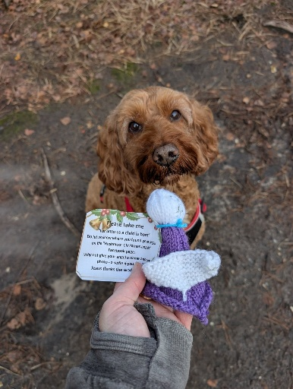
So, that’s a wrap…….. I think we can chalk up “RCA 2025” as another success. Well done everyone for all your hard and consistent work over the past months. You may well have already read the comments below on our Facebook page but here again are some of the messages we received from people who found one of our angels this Christmas.

“My daughter found [an] angel today she’s been named Layla after my angel Goddaughter who passed away 10 years ago today finding an angel on this day means so much”.

“I don't know how mine came to me - it was outside my front door this morning, I have stage 4 cancer and rarely go out, I didn't see the person running the angel transport but she's mine now - I'm calling her Lucy - a name shared by my Mum and Grandmother - she's clearly here to watch over me.”
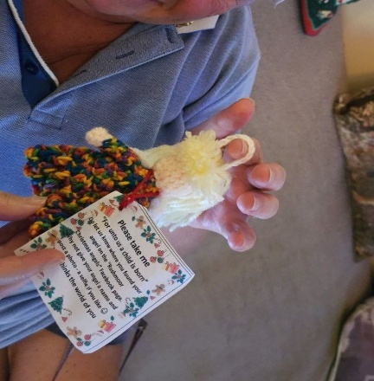
“Peanut and I were out for our little spin this morning along Alison’s road and we nearly drove past [a] little Angel but we turned back and I’m so glad we did! Little ‘Hope’ is something I desperately needed right now so I know she was meant for me. I will treasure her forever”

“Thanks for our angel, we have named him Shane Warne because of his Australian mullet hair style after the top cricketer”


“My brother found one of your Angels in amongst the Christmas Trees that he is selling in Stratford-upon-Avon! He asked me to pass on his thanks”

“I found [a] beautiful angel at Waterloo Station during a day out in London with my son today. I have named her Maggie after my late Mum, and she is now living happily in our Christmas tree in Stoke Mandeville. Thank you so much for leaving her for me to find, she is really special”

I was looking at where Facebook is suggesting the percentage of our angels “fly” to. Below are the top places followed by the top countries. Who would have thought 0.1% of our angels find their way to Poland eh….or Nigeria for that matter?

Aldershot 37% Farnborough 26.6% Farnham 4.7% Camberley 3.9%
Fleet 2.8% Bordon 0.7% Basingstoke 0.6% Guildford 0.6%
London 0.6% Woking 0.5%

UK 101.6% Australia 0.4% United States 0.3% Canada 0.2%
Ireland 0.2% France 0.1% Nigeria 0.1% Poland 0.1%
South Africa 0.1% Spain 0.1%

I look forward to seeing you all on Saturday 17 January.
David

