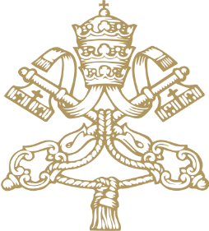

POPE LEO XIV
ANGELUS
St Peter's Square
Palm Sunday, 29 March 2026

___________________________________

Dear brothers and sisters,
At the beginning of Holy Week, our prayers are more than ever with the Christians of the Middle East, who are suffering the consequences of a brutal conflict and, in many cases, are unable to observe fully the liturgies of these holy days. Just as the Church contemplates the mystery of the Lord’s Passion, we cannot forget those who today are truly sharing in his suffering. Their ordeal challenges all our consciences. Let us raise our prayer to the Prince of Peace that he may sustain the peoples wounded by war and open concrete paths to reconciliation and peace.
I also wish to entrust to the Lord the maritime workers who have fallen victim to the conflict. I pray for the deceased, the wounded and their families. Land, sky and sea were all created for life and peace!
Let us also pray for all the migrants who have died at sea, especially those who lost their lives in recent days off the coast of Crete.
I greet and thank all of you – both Romans and pilgrims – who have taken part in this liturgy! Together, let us now turn to the Virgin Mary, entrusting all our prayers to her intercession. May she guide us during these holy days, so that we may follow Jesus, our Saviour, with faith and love.

