Roman Catholic Church
of
St Patrick and St George, Tidworth
Established 1912
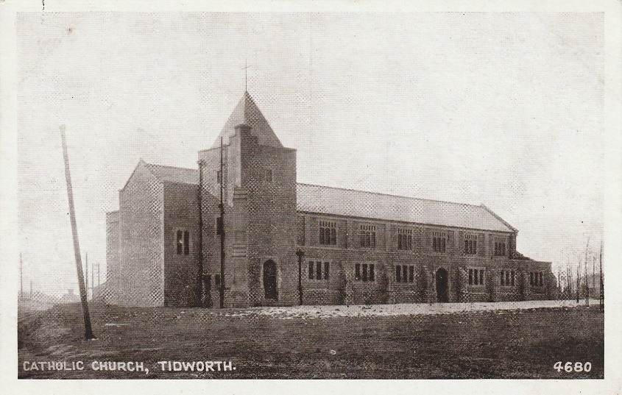
An Outline History
Revised 2022

Contents
Introduction 3
‘Tommy Atkins Church’ 2
Mgr Francis Browning Bickerstaffe-Drew 10
Opening of the Church 11
Dedication of Munster Fusiliers Window 13
Memorials and Features of the Church 15
First Entries in the Registers 24

Introduction
The foundation stone of the church of St Patrick and St George was laid on 22nd May 1911, and the church opened on 15 November 1912.
This history is based on an original article (titled “Tommy Atkins Church” as it had been largely funded by the soldiers of Tidworth Garrison) and recent research by parishioners, updated in 2022 to mark the 110th anniversary of the church. Much information has been obtained from the War Office file (32/4326/90103) in the Public Record Office in Kew.

‘Tommy Atkins Church’
  - How the Soldiers built their Place of Worship
The creation of Tidworth barracks commenced in the late nineteenth century, and among the essential facilities required for its completion were garrison churches representing all denominations. Early on, the garrison was equipped with a theatre which was used during the week for all kinds of recreation including dances organised for the troops. Such events necessitated a highly polished floor. On Sundays the same venue was used by the non-Catholic personnel for divine service, and the soldiers’ hard work on the floor presented a certain challenge to the efforts of the worshippers to remain upright on such occasions.
As Mooltan Barracks was not occupied at that time, Catholics were given permission to use the dining hall for their Sunday Mass. The congregation at this time consisted largely of the Royal Munster Fusiliers who were practically Catholic to a man, but with their ranks swelled on Sundays by the additional presence of wives and families, the venue soon proved inadequate.
The chaplain at this time Monsignor Count Bickerstaffe-Drew (who wrote as a novelist under the pseudonym ‘John Ayscough’). He lived with his elderly mother and travelled some sixteen miles to Tidworth to celebrate his two Sunday Masses, returning in the evening for Benediction.
A church was then to be built in 1910 but this was delayed, mainly due to lack of funds, to 1911/12. It was agreed that when built it would not be used by other denominations, “Archbishop Bourne preferred to vest the building in the Secretary of State on condition that as long as it was used for RC services it shall not be used for other denominations”. A proper designated church was badly needed, but the only assistance forthcoming from the authorities, after repeated applications, was the offer of a piece of ground. On investigation the land turned out to be a disused sand-pit, which had provided the builders of the barracks with the sand they required, and was now a dumping ground for garrison bully beef and plum-and-apple tins, bottles, etc.
The challenge of raising sufficient funds by donation for the building of a new church on the site proved to be a very problematic one. Apart from the Munsters, the Catholic members of other regiments stationed in the barracks were minimal, and this limited source of revenue was further constrained by the numerous ways that the average Catholic soldier had of disposing of his ‘shilling’ on pay day. It was agreed however, that each soldier of the Munsters should give a penny per week, with NCOs adding contributions of around 6d. Consequently it fell to the Munster NCOs assisted by a few of the Royal Army Medical Corps, 16th Hussars, and Worcesters to devise ways and means of finding the necessary money to make up the shortfall.
Their schemes were many and varied – some interesting and amusing. Regimental Sergeant Major Corrigan of the 18th Hussars, a native of Cork, introduced a system of small penalties levied from recruits who, having received suitable warning, compounded misdemeanours during training. These applied especially in the riding school where recruits had a propensity for hugging their mounts around the neck and whispering in their ear, or returning to terra firma by means not laid down by regulations. This, and other novel methods, produced an extra weekly sum which went to swell the fund.
Among the more conventional fund-raising efforts was the staging of a garden party, compete with a hired roundabout. An understanding was reached in advance with its proprietor that he should donate 10% of his takings, but on arrival, the gentleman wished to alter the arrangement having seen the large number of troops present. After due haggling and negotiation he agreed to hand over a lump sum of £15. At the start of the garden party business got off to a brisk start and money rolled in. Then across the happy throng the brazen notes of the bugler sounding ‘cookhouse’ rang out, and within minutes the soldiers dispersed to answer the call to ‘scoff’ – and unfortunately did not return. The roundabout proprietor departed, distinctly grieved that he had tinkered with the initial financial arrangements.
The plans were criticised in June 1910. The centre and side aisles were assessed as being too narrow. There was effectively, only one exit and it was ‘architecturally disappointing’ and there was a request from the War Office for a definite estimate of costs. The architect, Mr G W L Blount, rectified the perceived deficiencies in the plans. Meanwhile the Munsters continued preparations for the building of the church to begin. The Company Sergeant Majors asked volunteers to go round the barracks with barrows collecting surplus stones and bricks to be brought to the proposed site. Sick-paraded soldiers given light duties were then supplied with ground sheets and instructed to sit on the edge of the former sand-pit and fill it with the accumulated rubble. In this arduous way the site was levelled and prepared for the commencement of building, and the barracks were duly cleared of excess rubble in the process. At the opening ceremony of the church, the Bishop made reference in his sermon to this unusual procedure by stating that no Catholic church had been built on sand – and St Patrick and St George had been no exception – thanks to the spirit and determination of those men who had turned a sand-pit into a rock as solid as St. Peter’s in Rome.
Plans and costs were finalised in November 1910 and agreed by the Army Council on 2 December 1910, “subject to your (Mgr Bickerstaffe-Drew) meeting one or two minor points which have been urged by our architects”. The eventual building of the church proceeded with greater speed than was anticipated, much to the delight of all those who had laboured so hard to initiate the project. The only setback encountered was the announcement by the architect commissioned by the War Office that despite the superlative work undertaken to level the site, pillars would be necessary as an additional precaution against possible subsidence. The erection of these pillars represented another financial burden to the tune of an extra £150, but subscription started again and the extra amount was raised.
For Church of England purposes £1000 had been earmarked annually to the Chaplain General since 1888. For similar reasons £400 had been provided in aid each year since 1908 “towards the provisions and maintenance of buildings connected with each of the other denominations of Roman Catholic, Presbyterian and Wesleyan”. (This was the origin of the grant by the War Office of the £400 to the eventual cost of £1300). Financial outlay did not cease, however, with the completion of the building work. The new church required to be furnished, as only a few pews had been acquired during the occupancy of the dining hall, thanks to some of the Munster wives and others. Further seating was just one item needed among many. Despite the War Office’s donation of £400, the final outlay for the building and furnishings would total £2000 by the time of opening.
The War Office was to take the church over twelve months after completion “in case any difficulties arise as to the constructional or weather resisting qualities of the structure”. “The church may then be taken over and thereafter maintenance, heating, lighting and cleaning will be paid out of public funds”. The financial anxiety of Mgr. Bickerstaffe-Drew may well be imagined with the added realisation that Tidworth - known as a two year station – was soon to bid farewell to the Munsters. In all probability they would be replaced by a non-Catholic regiment. The same was likely to be the case with the departing 3rd Worcesters and the 18th Hussars, whose Catholic members had also worked so hard to raise funds.
At that time it was estimated “that as 15% to 16% of the Army are Roman Catholics, a large station like Tidworth could in almost no conceivable circumstances not have a fair proportion of RCs. It was agreed that they could have sole use of the building.” What was happening was an equalisation of the treatment between the RC Church and the Church of England. Some consolation was forthcoming at the official opening at which a large collection was taken which enabled Mgr. Bickerstaffe-Drew to pay off a large sum of interest. In other ways, too, the opening Mass proved a success beyond all expectations. The church was packed to capacity with a congregation including many non-Catholics and overflowed outside the building. A large number of confirmation candidates occupied the front portion of the church together with adult converts to be received into full communion, many of them brought to the faith through the example and good offices of the Irish maids employed by the families of local officers.
A contemporary account, from the Salisbury Journal 23 November 1912, of the opening is at page 11.
During the church’s early days, Mgr Bickerstaffe-Drew very rarely visited Tidworth on weekdays since he lived so far away. For an Army chaplain this was to prove a serious problem, as highlighted by the unfortunate death of a Munsters’ wife without the consolation of the Last Sacraments. Representations were made by the Munsters to the War Office asking for their chaplain to be resident in the barracks. A partial solution was to be the acquisition by Mgr Bickerstaffe-Drew of a quaint early new motor car, known as the ‘wheelbarrow’, which enabled him, provided the car thought it right, to travel around with greater speed and ease.
By now, however, international events were dictating the pace of change in Tidworth. The next trooping season saw the departure of the Munsters to Aldershot (they departed on Saturday 16 November 1912), while the Worcesters transferred to Dover. Their successors were not to have time to become involved in the building fund, or anything else, as the outbreak of war in 1914 caused almost everyone from Tidworth to be mobilised, the troops going to the front and their wives and children to their native hearths. The Australians and Canadians, however, (most of whom were Catholics) were soon to arrive to take their place, and consequently provided the means whereby the church building debt was eventually paid off by 1918.
Mgr Bickerstaffe-Drew went overseas with the first batch of troops and was succeeded by Father Fitzmaurice SJ whose introduction to soldiering was harder than the average recruit. No provision whatsoever had been made for him by the authorities. Fr Fitzmaurice was obliged to live in two tiny rooms in the church tower in the most basic conditions. Thankfully, at least the provision of meals was agreed with one of the officers’ messes. He was not to have much time to enjoy them, however, since orders to proceed abroad soon followed. With his departure, Fr Oddie of the Brompton Oratory arrived in Tidworth and took up residence in the cramped accommodation of the church tower – by now already developing leaks in addition to constant draughts. It was to be some time yet before the chaplain was offered accommodation in part of the Warrant Officers’ quarters in Mooltan Barracks.
Fr Oddie won not only the hearts, but also the souls of a large number of troops. His cheerful disposition, combined with a keen sense of humour, proved a veritable silver lining to the many dark clouds that disheartened the troops awaiting their turn to travel across the water. All too soon, Fr Oddie was also to receive his marching orders.
A succession of Army chaplains took charge of Tidworth and its church in the years that followed. The official consecration finally took place during the war with, regrettably, none of the original founders present.
Among many chaplains serving in Tidworth up to the present day, notable personalities were never in short supply. Of particular note, perhaps, was Father Carden who later met his death at the hands of a native servant in Egypt. His contribution to enrichment of the church was a beautiful organ and the erection of altar rails in memory of Mgr Bickerstaffe-Drew.
Fr Carden’s successor, Mgr Mullins, was to further embellish the church with a new high altar, and Stations of the Cross sculptured in relief. These were coloured to compliment the stained glass windows presented by the Munsters and the Worcesters. These features, including a pulpit donated by Major Chichester, were among many items destined to undergo removal – or significant change – following the liturgical changes of the Second Vatican Council in the 1960s.
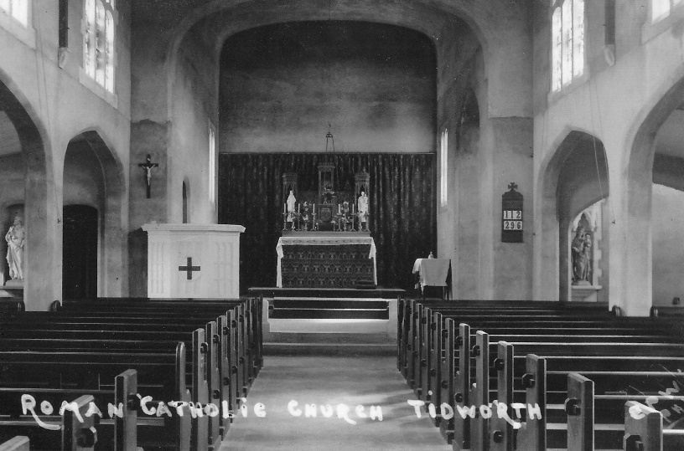

Mgr Francis Browning Bickerstaffe-Drew
  - 1858 – 1928
Mgr Bickerstaffe-Drew was born in Headingly, Leeds on 11 February 1858, the son of the Rev’d H Lloyd Bickerstaffe and Mona, the daughter of the Rev’d Pierce William Drew. He became a Catholic in 1878 whilst studying at Oxford.
He entered formation for priesthood at St Thomas’ Seminary, Hammersmith and was ordained as priest in 1884, later joining the Army Chaplains’ Department. In addition to his time in Tidworth, he served in Plymouth and Malta, and during the Great War, in France, twice being mentioned in dispatches.
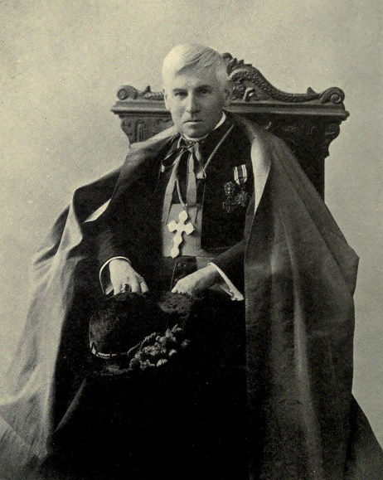
He received a number of papal honours, being appointed Protonotary Apostolic, a Knight of the Holy Sepulchre, the Cross pro Ecclesia et Pontifice (from Pope Leo XIII) and a personal jubilee medal from Pope Pius X.
He published memoirs, a book of impressions of America, and twenty novels (under the name ‘John Ayscough’) including ‘Rosemary’, ‘A Roman Tragedy’
Mgr Bickerstaffe-Drew died 3 July 1928 in Salisbury, and is buried in Winterbourne Gunner, where he had lived with his mother from 1909 until her death in 1916.

Opening of the Church
A contemporary account, from the ‘The Tablet’ 23 November 1912.
On the afternoon of Friday in last week, the new Garrison Church for Roman Catholic troops stationed at Tidworth was opened by the Bishop of Clifton. The church was filled to overflowing with a congregation numbering over a thousand, of whom seven hundred were troops, and the remainder wives and children of Catholic soldiers. No invitations were issued to outsiders, as it was desired that every available place should be given to the most nearly interested – the members of the congregation itself. At three o’clock the Bishop of Clifton, supported by the Right Rev Mgr Bickerstaffe-Drew KHS SCF, the Rev J Lyons, secretary to his lordship, and the Rev J C Dunphy CF, entered the church in procession, and advanced to the sanctuary during the singing of the ‘Veni Creator.’ Arrived at the altar, the Bishop dedicated the church and proceeded to the pulpit, where he delivered a striking discourse, at the end of which his lordship spoke of the thanks he would desire to record to all who had helped in the good work of building the church; to the Chaplain, the Right Rev Mgr Bickerstaffe-Drew, by whom the scheme had been originated, and on whose shoulders lies the sole and undivided financial responsibility; to the architect, Mr George L W Blount, of Salisbury, for the beauty of the building, and for his rigid economy in carrying it out; to the soldiers themselves, who had been so generous in their offerings, and especially the Royal Munster Fusiliers; and finally to many non-Catholic friends and well-wishers, who had, with the utmost goodwill and kindness shown their interest in the work, and helped it by collecting money among Catholic acquaintances, and given valuable help in the organising of successive entertainments, etc. In conclusion, his lordship spoke in words touching farewell and counsel to the battalion that, in a few days, would leave Tidworth for another station – the Royal Munster Fusiliers.
After the sermon the Bishop administered confirmation, and Benediction of the Blessed Sacrament ended the beautiful but simple service. A noteworthy feature was the fact that no cassocked and surpliced acolytes appeared – the service of the altar was carried out by soldiers, and the reverence and devotion of their demeanour, as of that of the many hundreds of soldiers in the church, was singularly striking.
Architecturally, the building follows perpendicular lines, its detail being governed largely by the material employed in its construction – reinforced concrete. Designed to seat 600, the plan consists of a nave, side aisles, sanctuary and lady chapel, whilst in a square tower at the N.E. corner is contrived heating chamber, sacristy and priest’s chamber. The external treatment is flint facing, with Bath stone dressing; stained glass windows have been presented by Major Child and others (the work of William Camm, of Birmingham). The design of for the church and fittings is by Mr George L W Blount of Salisbury, under whose directions the contract has been most satisfactorily carried out by Messrs W E Chivers and Sons, of Devizes.

Dedication of Munster Fusiliers Window
This report was in the Salisbury Journal on 23 August 1913
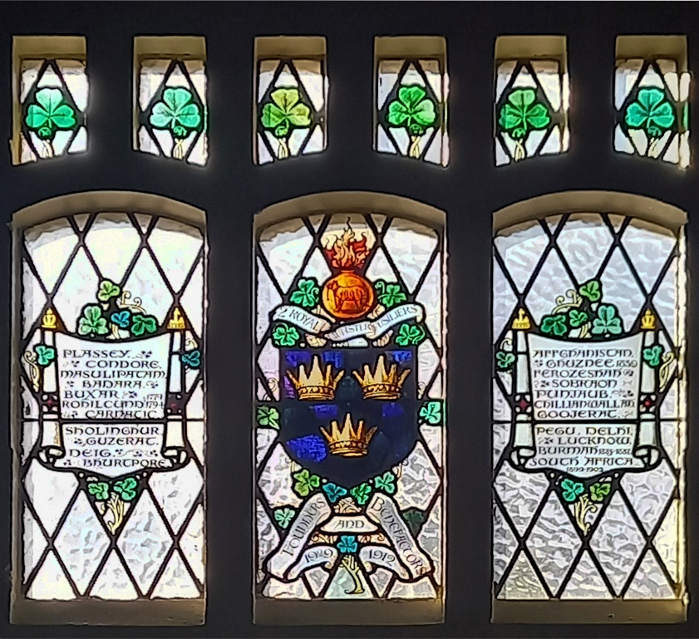
“There was a very interesting function at Tidworth on Sunday afternoon, when General Sir H L Smith Dorrian KCB in the St Patrick and St George’s Roman Catholic Church unveiled a stained glass window which has been presented by the 2nd Battalion Royal Munster Fusiliers in memory of their stay on Salisbury Plain. Almost to a man the Royal Munster Fusiliers are Roman Catholic, and it was very largely through their efforts that the Roman Catholic Church was built, and the senior chaplain to the Forces, the Right Rev’d Monsignor F B D Bickerstaffe-Drew KHS looks with a good deal of pride on the Munster Fusiliers. The window which has been erected to their memory is in the clerestory and is of three lights. The central light gives the arms of the Royal Munster Fusiliers with the Royal Bengal Tiger on grenade for the crest. Under it is the inscription:
2ND ROYAL MUNSTER FUSILIERS
Founders and Benefactors
1909 – 1912
The side lights are occupied with two loop mantles or scrolls, on which are inscribed the battle honours of the regiment. The senior chaplain took the service, being assisted in the various duties by men wearing uniform. General Sir H Smith-Dorrien was supported by Major General H S Rawlinson Bart CVO CB commanding 3rd Division; Brigadier-General F W N McCracken CB DSO, General Officer Commanding 7th Infantry Brigade; Major Hope Johnson, Colonel Knatchbull, and a deputation of three officers and 11 non-commissioned officers and men from the Royal Munster Fusiliers, now at Aldershot. The chaplain referred in a general way to the position of the Roman Catholic faith among soldiers, and spoke of the great help which the officers and men of the Munsters had been to him in the foundation of that church. The screen, which covered the windows, was then released by General Sir H Smith-Dorrien, who said it was perfectly true that he was there to show his sympathy with the Roman Catholic faith. He was also pleased to be there because it brought him in touch with the battalion which left him not very long age, a battalion composed almost entirely of Roman Catholics, and which, much to his regret, had departed. Although gone, they had left behind them a name for efficiency as soldiers, second to none. They realised that in addition to beautifying the House of God with that window, it was the most appropriate way of marking their sojourn at that station, and of showing their gratitude for blessings received while at Tidworth. The Royal Munster Fusiliers had most generously erected the window, which he unveiled to the honour and glory of the Almighty.”

Memorials and Features of the Church

Windows
In addition to the Munster Fusiliers window, we are blessed with a number of other stained-glass windows.
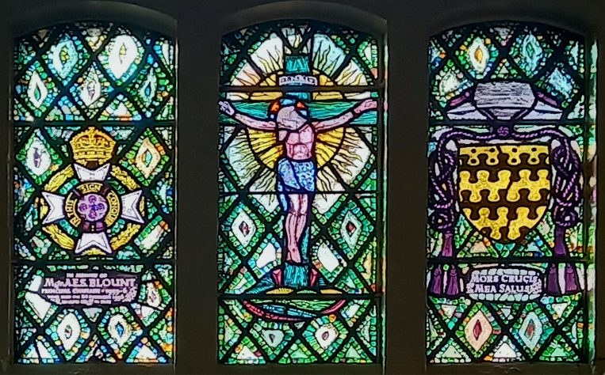
The memorial window to Mgr A E S Blount was blessed by Archbishop Matthews on 4 August 1957.

Two other windows commemorate the Worcester Regiment and The Queen Alexandra’s Royal Army Nursing Cops (1960).
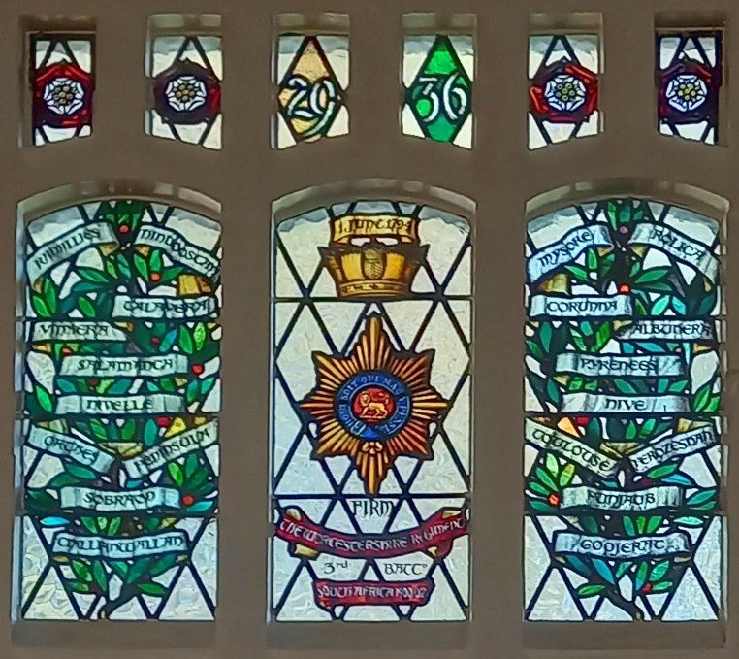
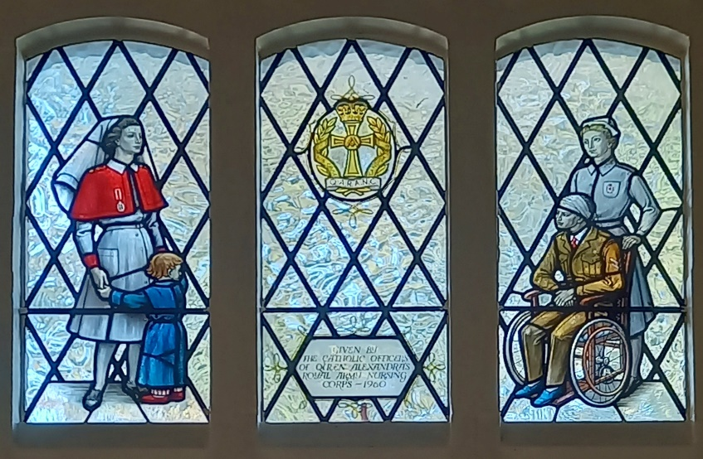
A further window, in the baptistry and depicting a family bringing their child for baptism, is a memorial to Fr McKenna.
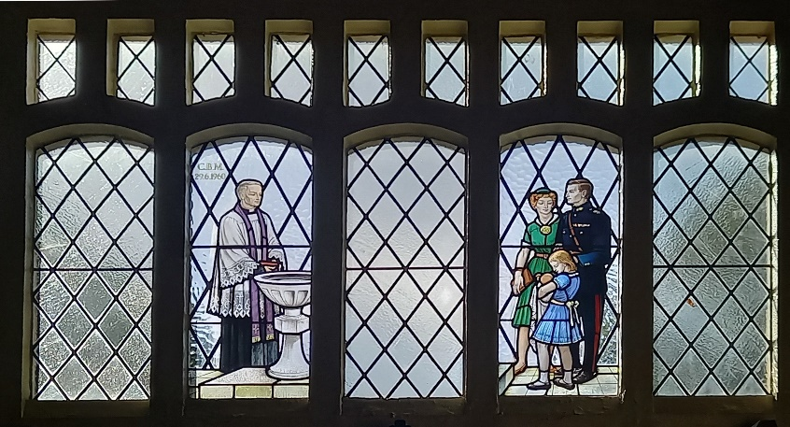
The blessing and inauguration of the Millennium windows by the Rt Rev’d F J Walmsley CBE, RC Bishop to HM Forces, took place on 26 November 1997. These commemorate campaigns/operations since the Second World War.
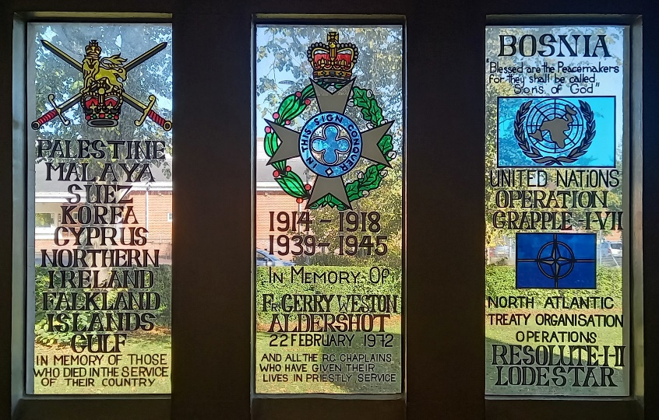

The Pews
Many of the pews carry brass commemorative plaques bearing the names of those who donated them to the church.
The pews were probably presented for the use of the parishioners when Mass was celebrated in the Mooltan Barracks Dining Room. This would account for why the dates are four years prior to the opening of the church.
Those bearing plaques were presented by:
- The Royal Scots Greys 1908
- The Cameron Highlanders 1908
- 4th Battalion Middlesex Regiment 1908
- Lt Stapleton-Brotherton, Royal Fusiliers 1980
- NCOs and men of ‘F’ Company, the 2nd Royal Munster Fusiliers 1910
- Sgt J England, PB Staff and Details, Royal Inniskilling Fusiliers 1908
- Provisional Battalion 1908
- Details, Connaught Ranger 1908
- Mrs Clarke, Mrs Williams & Friends 1908
- Col M Kerin AMO 1908
- Women of the 2nd Royal Munster Fusiliers 1910

Holy water Stoops
Count Bertand De Comminges of Paris (Capt J W Arnold).
In Remembrance of Rev’d M Dowling (1954-1957)

Stations of the Cross
Presented by the following:
- Men of 2 Battalion the Loyal Regiment
- Rt Rev Monsignor M J Mullins DCL
- 9 Battalion Queen’s Royal Lancers
- Lt Col L D Daly DSO OBE, 51st Kings Own Yorkshire Light Infantry
- 5 Battalion, Royal Tank Corps
- Mr and Mrs F May
- Members of the Congregation
- Mrs Johanna Pitts and family
- Lt Col Berkeley CMG DSO OBE
- Mr and Mrs Ryan
- Brig F B Hurndall MC, 2nd Cavalry Brigade
- Ruth Pigot-Moodie and son
- 2nd Cavalry Brigade
- Lt Col and Mrs S M Loughnan

Other Features
Statues of the church’s patron saints, St Patrick and St George, are situated in the sanctuary.
At the rear of the altar there is a screen on which the following figures of saints are shown, from left to right:
St Martin, St Alban, St Michael the Archangel, St George, St Sebastian and St Joan of Arc.
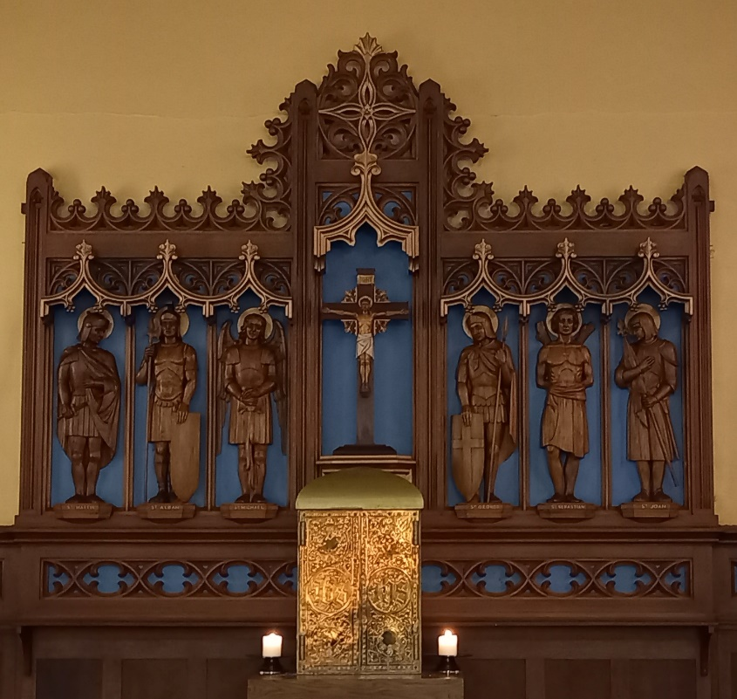
Around the sides of the sanctuary there are the badges of different regiments who served in the area, but some are undoubtedly omitted.
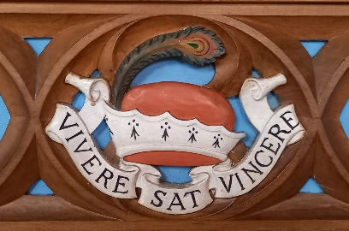  Earl of Sefton | 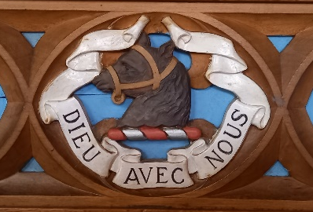
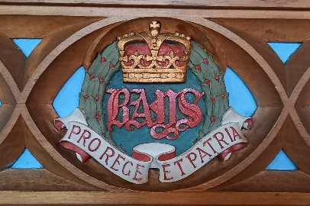  The Queen’s Bays | 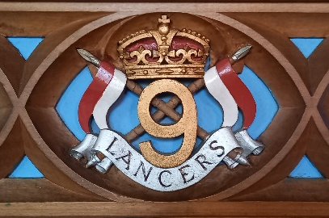  The 9th Battalion Queen’s Royal Lancers
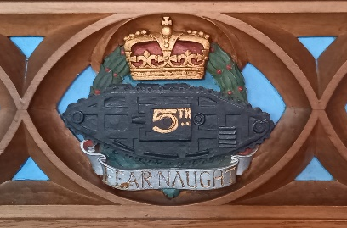  The 5th Battalion, Royal Tank Corps | 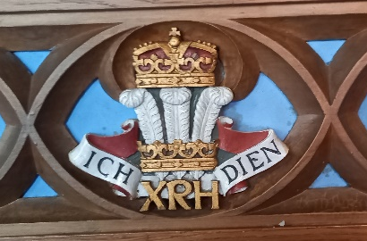  The 10th Royal Hussars
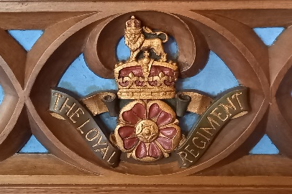  The Loyal Regiment (North Lancashire) | 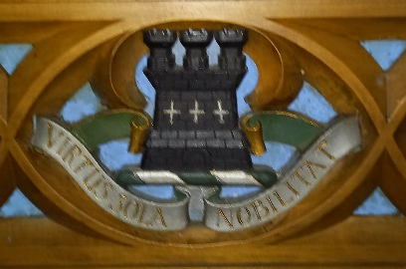
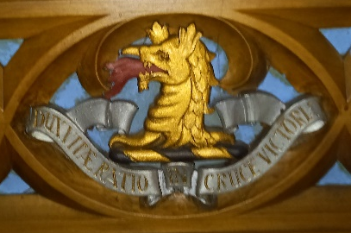 | 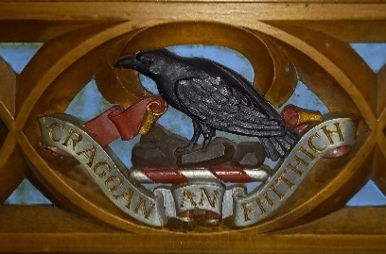  MacDonnell of Glengarry
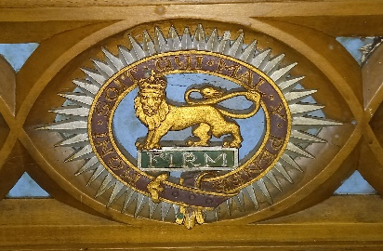  Worcestershire Regiment | 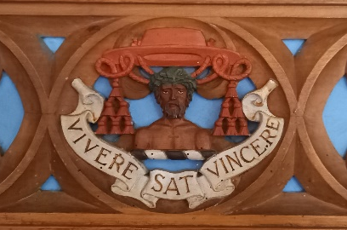

At one time there was a pulpit at the right of the sanctuary. It was dismantled, divided into two smaller pulpits erected on each side, but both were subsequently removed.
Altar rails also once circled the sanctuary steps but have also been removed.
A Baptistry Chapel is located to the right of the sanctuary, having originally been the Lady Chapel, and subsequently housed the organ and choir stalls, and then been a Blessed Sacrament Chapel before the Tabernacle was returned to it’s earlier position.
A bungalow was built in the 1960’s to accommodate the chaplain and is situated beside the church.
In the choir loft at the rear of the church is a large pipe organ, sadly no longer in use.
Mass Board  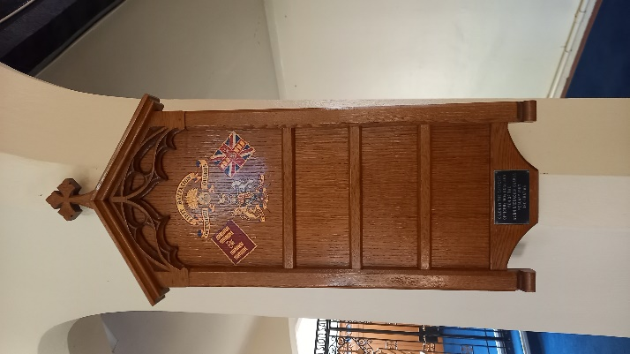 | Hymn Board  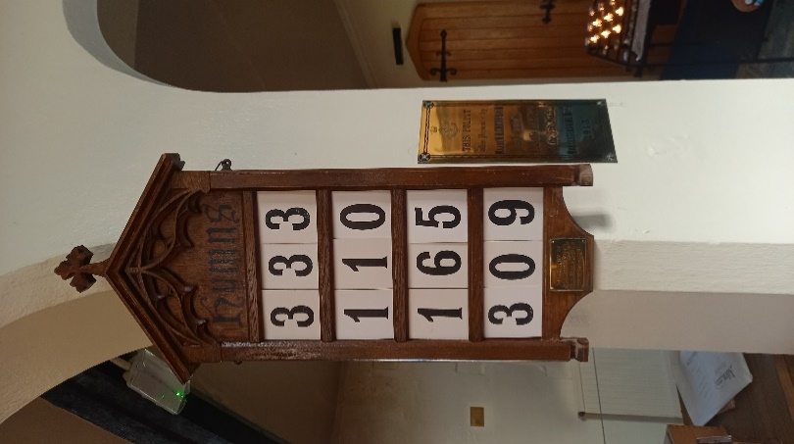
Officers and WOS, NCOs and men, 1st Battalion Grenadier Guards | Lt H H Headen, 2nd RMF (Killed in Cairo). From the RMF Band.

First Entries in the Registers

First Baptism
James William Castle
Son of Eli and Alice (nee Drinkwater)
Born 25th February 1889
Baptised on 10th March 1912
by Monsignor Bickerstaffe-Drew

First Marriage
Alexander Sutherland and Gertrude Roche
13th December 1911

First Confirmation:
May Bridget Hall
14th November 1912
by Bishop George Ambrose Burton

