At the start of the season of Advent, I was fortunate enough to visit the Benedictine Monastery in Ampleforth, North Yorkshire as part of the Bishopric of the Forces UK Military and Civil Servants Retreat. On arriving in my room, three books were laid on the desk - the Bible, the Rule of Saint Benedict, and Saint Benedict’s Prayer Book. Printed on the very first page of the latter are the simple words – ‘Always we begin again’. I spent the next four days with this phrase in my mind trying to understand its significance and why it had made such an immediate impression on me.
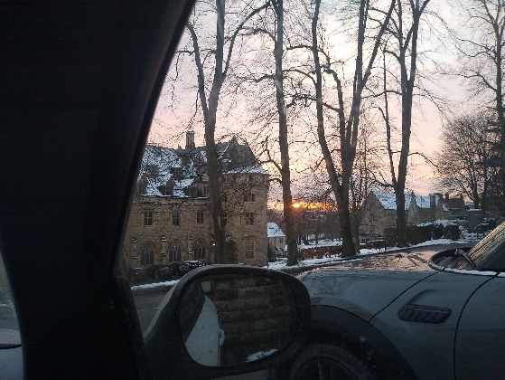
The view that greeted me parking the car
A snowy drive into Ampleforth
In our busy home and work lives, particularly with the added burdens generated by greater connectivity, social media emphasising a seemly overwhelming pressure to conform and 24hr news giving us minute by minute developments in the world it appears that there is very little space for individual reflection and renewal.
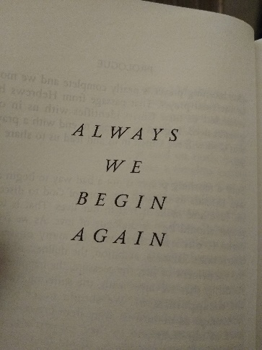
Saint Benedict’s Prayer Book

Society at large would have you think that there are certain pre-arranged times for renewal and reflection on your personal goals, relationships, and well-being. These pre-ordinated times seem to be New Year, Easter or start of spring and maybe on a significant birthday.
The more I reflected on the phase ‘Always we begin again’, I started to think that renewal was not how society would have you believe. Rather than being an organised activity that had certain dates allocated to it through the year, it dawned on me that renewal was a continuous, week by week, day by day, minute by minute and even second by second activity.

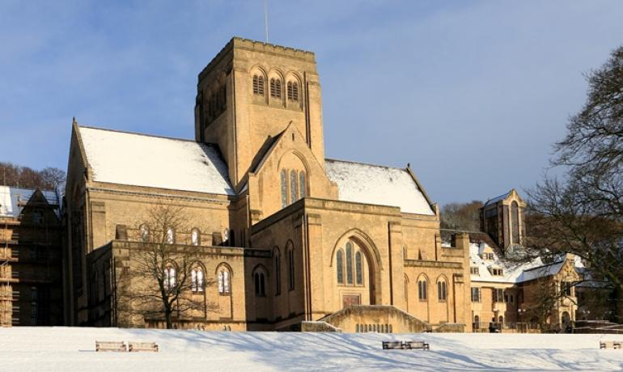
Now this view of renewal probably isn’t popular in our modern society because it may not be responsible for selling as many gym memberships, holidays, coffee machines or cars as would be liked. However, what it does have is the power to free us from a huge amount of worry and anguish about ourselves.
Failure is part of modern life, not living up to our own standards is a fact and falling short in relationships is inevitable. Society teaches us that we can put all this right with a few New Year’s resolutions and a new juicer or diet; but that isn’t what Saint Benedict is telling us through the words ‘Always we begin again’.
‘Always we begin again’ offers a constant invitation to renewal. Every moment that passes is history and cannot be altered, what has been, has been, what is done, is done; however, the future is full of endless opportunity; to right wrongs, to be a better husband, wife, son, daughter, friend, boss, or colleague, to offer hope to those who need it and to live life to the full (Jn 10:10).
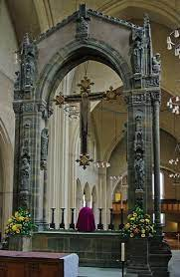
Four days at the monastery offered a space to stop, reflect and refresh. Each person who attended came for different reasons and from a range of backgrounds. Some were seeking answers and direction about what their next steps in life or career should be, some were curious about what a week in a monastery would entail, some just needed to step off the ‘treadmill’ of life for a few days and gather themselves before heading back into a demanding role. The welcome and invitation was universal - I was a stranger and you welcomed me (Mt 25:35).

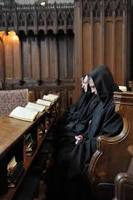
I quickly noticed a common thread seemed to emerge in everyone. Irrespective of what brought them to attend or what was going on in their lives, there was a genuine openness to explore what was on offer without preconception or prejudice. A simple response to the offer ‘come and see’ (Jn 1:39).
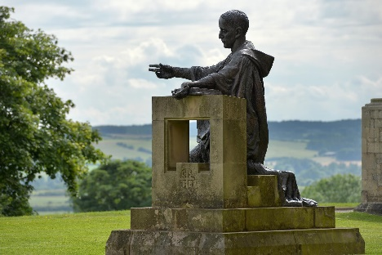
A wise and experienced member of the Benedictine community was assigned to our group, to facilitate the sessions that punctuated our time at the monastery. Fr Richard had been a member of the order since the 1960’s and he had the air of a man who had heard everything and had the wisdom to navigate through the questions and issues we threw at him. He led sessions on a range of topics, but of particular interest to the group were those on spiritual resilience, mercy, and the meaning of service. Furthermore, he ensured that each person had the opportunity to speak with him personally and privately through the week to share with him why they had come and perhaps to get his support or advice about a particular issue or question they were grappling with. Although these conversations were private to each person, everyone seemed to be grateful they had taken the opportunity to speak with him and benefit from his perspective and insight.
The monastery has a rhythmic and calming routine of prayer, worship, and reflection. Furthermore, its position in a beautiful valley in North Yorkshire offered the opportunity to simply go for a walk or run in the stunning countryside and find solace and peace in nature and the wonder of creation.
When the four days were over, leaving proved to be more difficult than anticipated as the welcome had been so positive and inclusive. The monastery had proved itself to be a sanctuary in modern life and the benefits of time spent there will be felt for months or even years to come. The daily routine of monastic life certainly resonates with that of serving in the military, as adherence to a structure can offer a sense of security but uniquely there is a silence in the routine that opens a space for an inner voice to be heard, perhaps its God, the holy spirit or just the sound of the soul finally being offered an opportunity to speak.
When I listened to this voice, I heard,
Always we begin again.

