“Rushmoor Christmas Angels” Newsletter November 2025

Hello everyone,
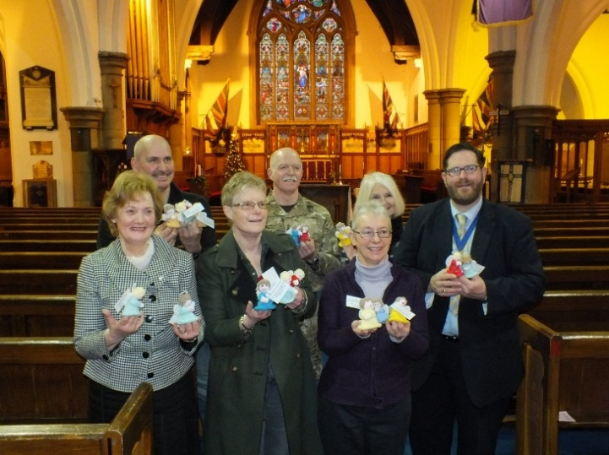
Welcome to “Rushmoor Christmas Angels” newsletter November 2025. A special welcome to those of you who have recently joined us and are maybe receiving this newsletter for the first time.

Can you believe it, we launch RCA 25 next month? How quickly has that come around?

The social media countdown is all set up on our Facebook page ready to countdown the days until the launch of this year’s project.

If you are on social media would it be possible, once these “Countdown” posts start to appear to share them on your own social media platforms.
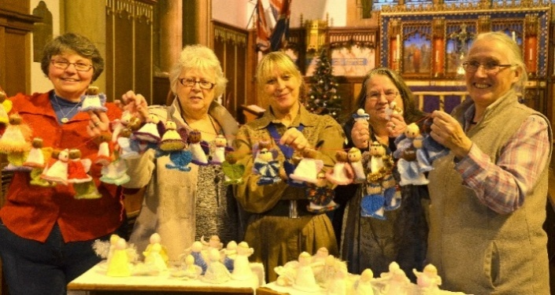
We have noticed over the years that we don’t seem to be seeing as many pictures of our angels as we have done in the past. This may be because Facebook algorithms are such that the more that various posts are “engaged” with, (this could include “likes”, shares” and comments”) the more Facebook believes that there is an interest in said posts and in turn “promotes” these posts across the platform. Maybe we need to be a bit more proactive in interacting with RCA instead of waiting for posts to appear on our Facebook page……. You never know, it might work!....if not we will think of something else for next year.
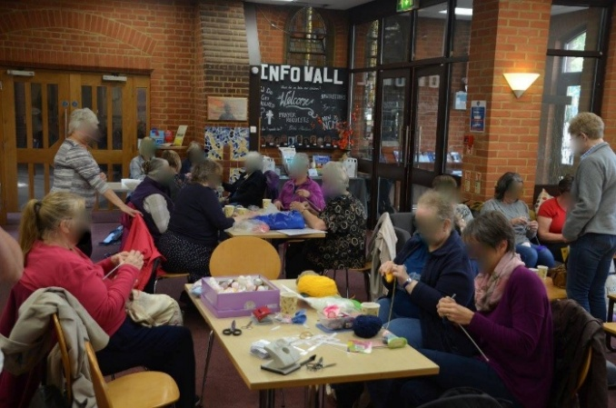
The two pictures above were taken at the Royal Garrison Church at the launch of RCA back in 2015 (how young we look?), and now here we are in our 12th year!

Just a few points – If possible we need to make sure that as many of our angels as possible are “with us” on Saturday 22nd November at our final “Knitting party” this year. That way we can see to it that all angels are labelled, “winged” and bagged ready to be taken away at our dedication service on the following Friday (28th).

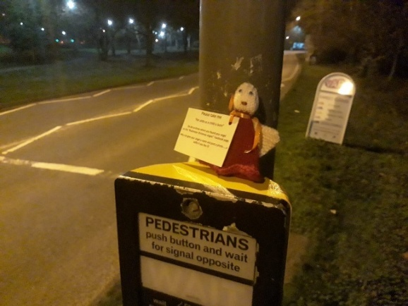
I was thinking back to the early days of “Rushmoor Christmas Angels” when RCA didn’t begin placing our angels until the second week in December and going by the picture above no one knew our identities either

If my memory serves me right we produced 3,000 angels in our first year of knitting, but now we have learnt that we need the whole of December to make sure all of our angels get out in time ready to find their Christmas homes.

David

